size (1000, 1000);
background (#ffffff);
//star
stroke (#0000ff);
strokeWeight (4);
line (400, 300, 600, 300);
line (600, 300, 435, 425);
line (435, 425, 500, 225);
line (500, 225, 565, 425);
line (565, 425, 400, 300);
//innerhex
stroke (#00ff00);
strokeWeight (6);
line (400, 300, 500, 225);
line (500, 225, 600, 300);
line (600, 300, 565, 425);
line (565, 425, 435, 425);
line (435, 425, 400, 300);
//outerline
stroke (#0000ff);
strokeWeight (4);
line (445, 260, 365, 150);
line (555, 260, 640, 150);
line (585, 365, 695, 400);
line (500, 425, 500, 535);
line (415, 365, 295, 400);
//outerhex
stroke (#00ff00);
strokeWeight (6);
line (365, 150, 640, 150);
line (640, 150, 695, 400);
line (695, 400, 500, 535);
line (500, 535, 295, 400);
line (295, 400, 365, 150);
//weirdline
stroke (#ff0000);
strokeWeight (8);
line (400, 300, 640, 150);
line (500, 225, 695, 400);
line (600, 300, 500, 535);
line (565, 425, 295, 400);
line (435, 425, 365, 150);
save ("star_HaiLin_260902.png");

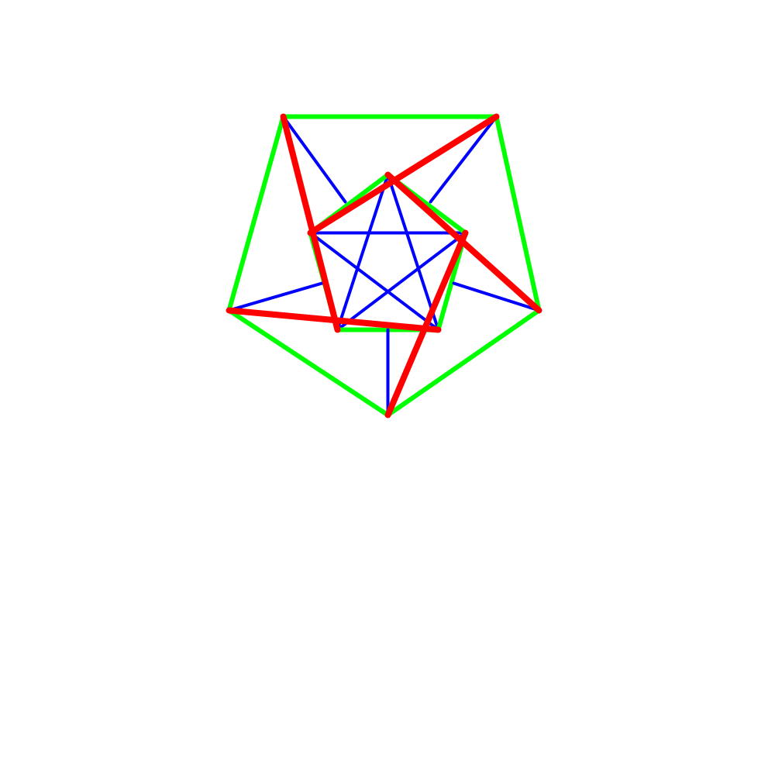

size (1000, 1000);
background (#ffffff);
//cat head
stroke (#000000);
strokeWeight (4);
line (200, 800, 300, 100);
line (300, 100, 400, 300);
line (400, 300, 600, 300);
line (600, 300, 700, 100);
line (700, 100, 800, 800);
//cat whiskers
stroke (#333333);
strokeWeight (1);
line (300, 550, 150, 500);
line (275, 600, 150, 600);
line (300, 650, 150, 675);
line (700, 550, 850, 500);
line (725, 600, 850, 600);
line (700, 650, 850, 675);
//cat eyes
stroke (#555555);
strokeWeight(3);
//left
line (325, 450, 450, 450);
line (410, 450, 410, 475);
line (410, 475, 450, 475);
line (450, 475, 450, 450);
//right
line (550, 450, 675, 450);
line (635, 450, 635, 475);
line (635, 475, 675, 475);
line (675, 475, 675, 450);
//cat mouth
stroke (#222222);
strokeWeight (4);
line (400, 700, 430, 650);
line (600, 700, 570, 650);
line (400, 700, 450, 750);
line (450, 750, 500, 700);
line (500, 700, 550, 750);
line (550, 750, 600, 700);
save ("cat_HaiLin_260909.png");

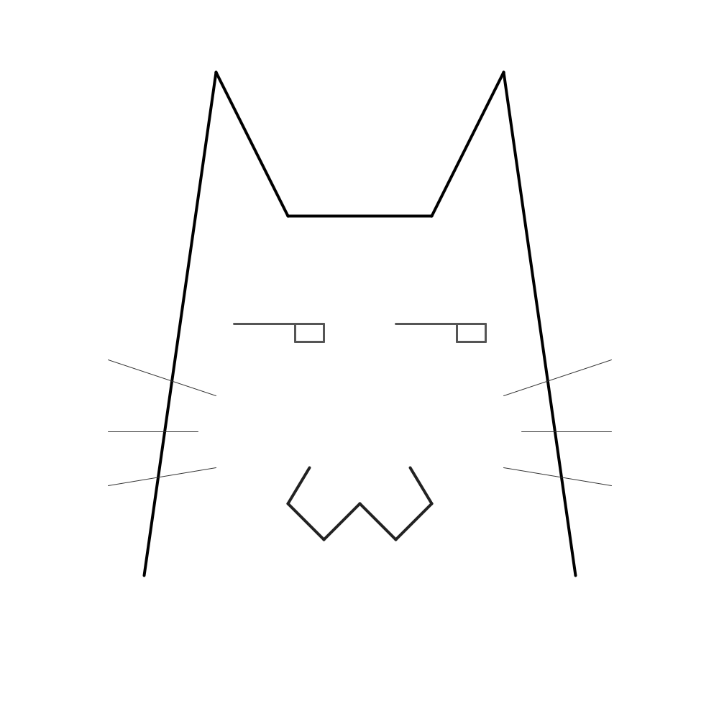

size (500, 500);
background (#ffffff);
//inner
stroke (#ff0000);
strokeWeight (2);
line (250, 190, 250, 220);
line (250, 280, 250, 310);
line (190, 250, 220, 250);
line (280, 250, 310, 250);
line (210, 210, 230, 230);
line (290, 210, 270, 230);
line (210, 290, 230, 270);
line (290, 290, 270, 270);
//mid
stroke (#00ff00);
strokeWeight (2);
line (250, 120, 250, 160);
line (250, 340, 250, 380);
line (120, 250, 160, 250);
line (340, 250, 380, 250);
line (170, 170, 200, 200);
line (330, 170, 300, 200);
line (170, 330, 200, 300);
line (330, 330, 300, 300);
//outer
stroke (#0000ff);
strokeWeight (2);
line (250, 80, 250, 100);
line (250, 400, 250, 420);
line (80, 250, 100, 250);
line (400, 250, 420, 250);
line (140, 140, 160, 160);
line (360, 140, 340, 160);
line (140, 360, 160, 340);
line (360, 360, 340, 340);
save ("firework_HaiLin_260902.png");



size (1000, 1000);
background (#ffffff);
//lightning bolts
strokeWeight (6);
stroke (#FCC01E);
line (500, 300, 400, 650);
line (400, 650, 550, 550);
line (550, 550, 500, 800);
line (500, 800, 650, 450);
line (650, 450, 475, 525);
line (475, 525, 500, 300);
line (550, 550, 475, 525);
//L1
stroke (#FFE066);
strokeWeight (1);
line (300, 350, 260, 470);
line (260, 470, 320, 430);
line (320, 430, 280, 520);
//L2
stroke (#FFE066);
strokeWeight (2);
line (750, 350, 710, 470);
line (710, 470, 770, 430);
line (770, 430, 730, 520);
//L3
stroke (#FFF2B2);
strokeWeight (3);
line (180, 500, 140, 620);
line (140, 620, 200, 580);
line (200, 580, 160, 670);
//L4
stroke (#FFE066);
strokeWeight (4);
line (820, 500, 780, 620);
line (780, 620, 840, 580);
line (840, 580, 800, 670);
//L5
stroke (#FFE066);
strokeWeight (5);
line (300, 650, 260, 770);
line (260, 770, 320, 730);
line (320, 730, 280, 820);
//L6
stroke (#FFF2B2);
strokeWeight (6);
line (750, 650, 710, 770);
line (710, 770, 770, 730);
line (770, 730, 730, 820);
save ("lightning_HaiLin_290909.png");
